**Use the sentiment analysis prebuilt model in Power Automate**

1. Create a SharePoint list

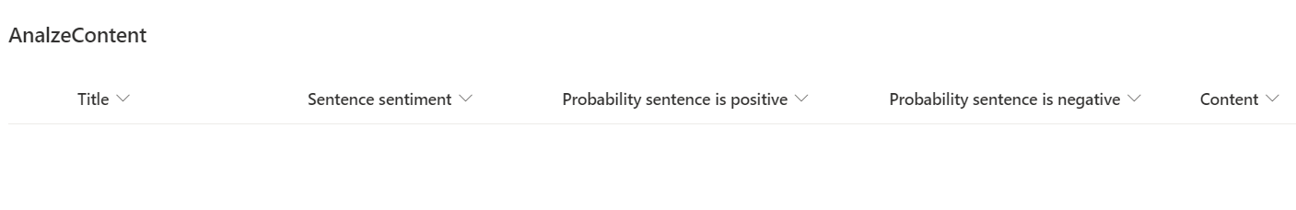

* 1. **Title**
  2. **Sentence sentiment**,
  3. **Probability sentence is positive**
  4. **Probability sentence is negative**
  5. **Content**

1. Go to Power Automate (flow.microsoft.com)
2. Select **My flows** in the left pane, and then select **New flow** > **Automated cloud flow**.
3. Name your flow, select **When a new email arrives** and then select **Create**.
4. Select **+ New step** > **AI Builder**, and then select **Analyze positive or negative sentiment** in the list of actions.

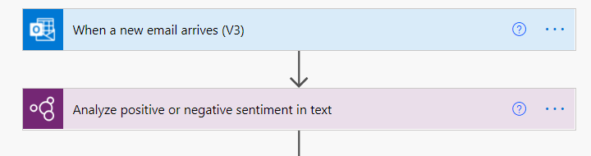

1. In the **Language** input, select or enter your language. **English**
2. In the **Text** input, select **body** from the **Dynamic content** list:
3. In the successive actions, you can use any columns extracted by the AI Builder model.
   1. Create an Item in SharePoint
   2. **Sentence sentiment**,
   3. **Probability sentence is positive**
   4. **Probability sentence is negative**
   5. **Body content**
4. Select **Save** on the top right, and then select **Test** to try out your flow.

